Hälsa Debuts America’s First Oat Yogurt in New York Metro and Tri-State Area
A new process makes healthier plant-based milks and yogurts

NEW YORK – June 1, 2018 – Hälsa, the first plant-based yogurt drink with a 100% clean label, debuts this month at 80 stores across the New York Metro and tri-state area. Hälsa, Swedish for health, is the maker of America’s first Oatgurt, a light and refreshing dairy-free drinkable yogurt made from organic Scandinavian whole grain oats, topped with organic berries and fruits.
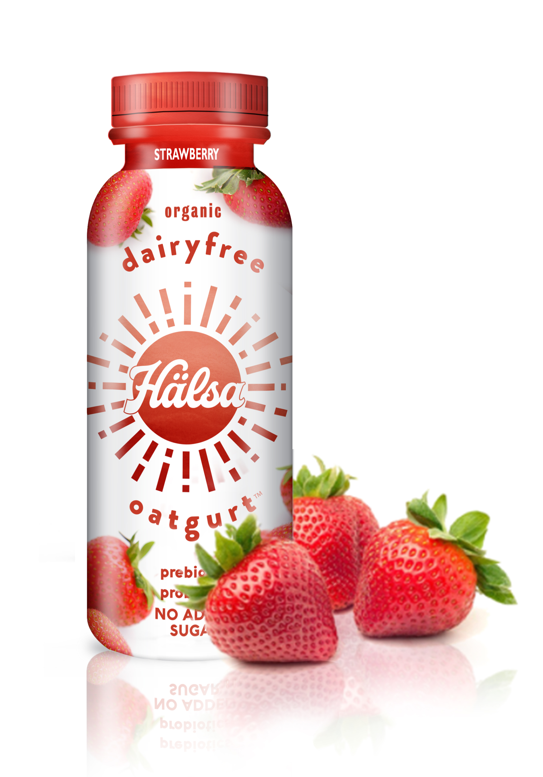

Organic Hälsa Oatgurt is available in four great-tasting fruit flavors – Organic Strawberry, Organic Blueberry, Organic Mango Pear, and Organic Apple Cinnamon, and boasts the following claims:

- 100% clean label
- No dairy, no soy
- No added sugar
- Prebiotics, Probiotics
- Certified Organic, Certified Kosher
- Only 120 – 140 calories per bottle

Gentle on the stomach with billions of live cultures and Bifidus, Hälsa is the first plant-based yogurt without a single artificial ingredient.

Removing the ‘processed’ from plant-based milks
Scandinavian-born founders Helena Lumme and Mika Manninen, who launched Simpli OatShakes in the U.S. in 2012, spent three years creating a new, more natural process to make plant-based milks and yogurts.

As the consumption of plant-based milks grows, consumers are starting to ask how these milks are made, and how healthy they truly are, Lumme and Manninen believe.

“The existing plant-based processes use enzymes to break down starch to sugar, depleting the drink of its nutrients. Then artificial ingredients like food gums and carrageenan are added. We set out to create a healthier and more natural process, and consumers will be able to taste the difference,” they add.

Hälsa’s 100% clean label starts with organic whole grain oats imported from Scandinavia, and using only organic fruits and berries. During the process nothing natural is removed or extracted, and nothing artificial is added. The sugar is naturally occurring in berries and fruit, with no artificial sweeteners or stevia added.

Aimed at health-minded shoppers and Millennials looking for products made of high-quality clean ingredients, Hälsa retails at $2.49 for an 8 fl oz. bottle.

For more information and a list of retailers, please visit halsafoods.com.

Images can be downloaded at halsafoods.com/media

Editorial Contact: Terri Slater, Slater PR / 561-487-7037 / terri@slaterpr.com

