FOR IMMEDIATE RELEASE

Hälsa 100% Clean Label Movement Is a Game Changer in U.S. Food Market
Wegmans Food Markets to Carry New Hälsa Clean Label Oatgurt Drinks
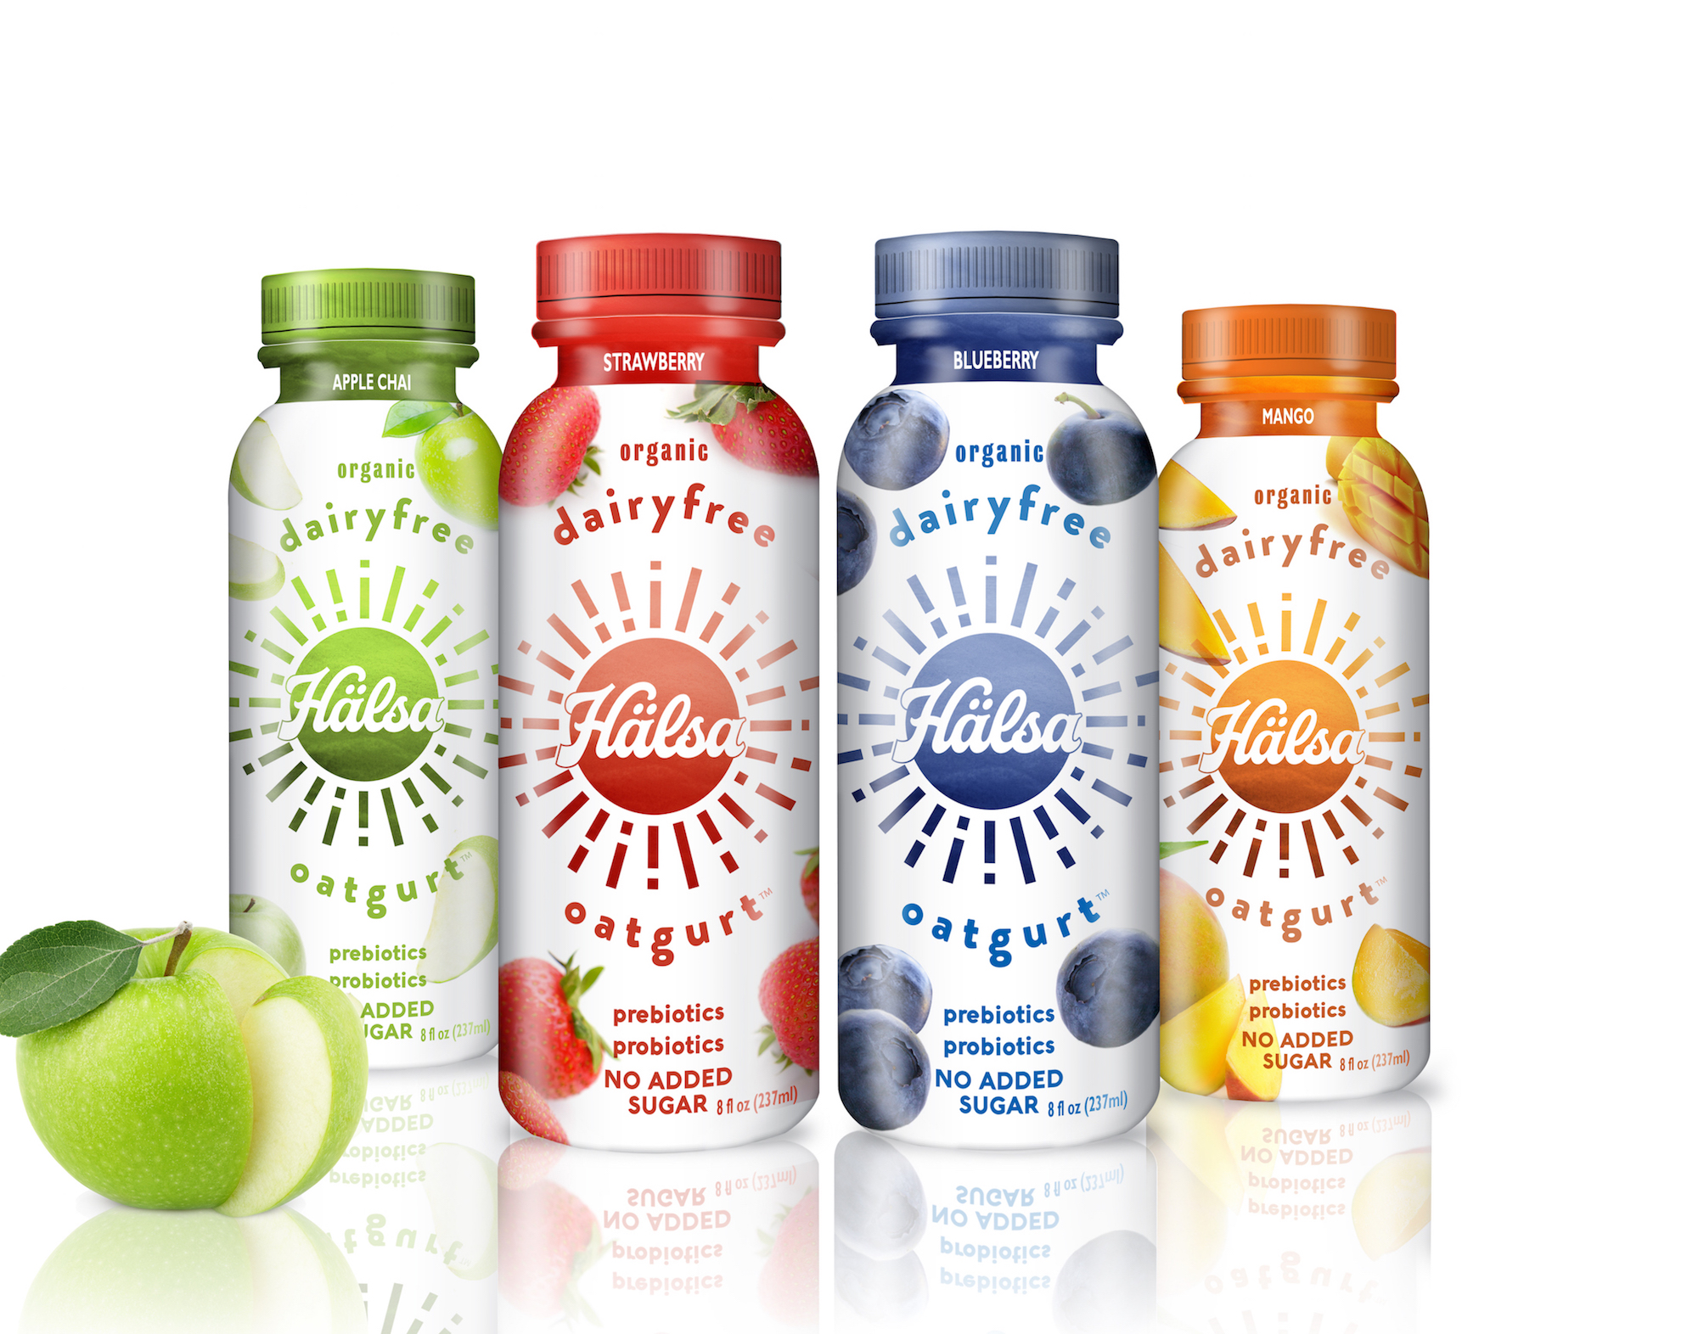
NEW YORK – August 28, 2018 – Today marks the formal launch of the “100% Clean Label Movement” lead by Scandinavian-born food entrepreneurs Mika Manninen and Helena Lumme, co-founders of Hälsa, which is Swedish for health.

The 100% Clean Label Movement has three principles:

- Clean Ingredients – grown by organic standards, sustainable farming practices, and low environmental footprint
- Manufacturing Process – no enzymes or synthetic ingredients used
- Final Product – free of all synthetic or processed ingredients

“Natural food products are doing many things right, but they still contain artificial ingredients. With our 100% clean label Hälsa Oatgurt we are raising the bar, and showing it’s possible to make plant-based beverages without using a single artificial ingredient,” stated Lumme and Manninen, whose Scandinavian background helped them to see the many shortcomings of the U.S. food industry and to create a solution. “It took 4 years of research to come up with 100% clean line of dairy-free products, and consumers are responding to this message.”

According to Innova Market Insights 75 % of consumers in the United States claim to read the nutritional and ingredient labels of food products, and nearly as many “strongly agree” it is important for food labels to contain mostly recognizable ingredients. Ninety-one per cent of U.S. consumers believe food and beverage options with recognizable ingredients are healthier.

Wegmans Food Markets is the first large supermarket chain to carry the new Hälsa drinkable yogurt. “Wegman’s relationship with their shoppers is unique, and we are honored to be among Wegmans new plant-based offerings this fall,” Manninen and Lumme say.

Hälsa, Swedish for health, is America’s first Oatgurt, a light and refreshing dairy-free drinkable yogurt made from organic Scandinavian whole grain oats, topped with organic berries and fruits.

Organic Hälsa Oatgurt is available in three great-tasting fruit flavors – Organic Strawberry, Organic Blueberry, Organic Mango Pear and boasts the following claims:

- 100% clean label
- No dairy, no soy
- No added sugar
- Prebiotics, Probiotics
- Certified Organic, Certified Kosher
- Only 120 – 130 calories per bottle

Hälsa retails at $2.99 for an 8 fl oz. bottle and can be found at Wegmans Food Markets and other leading health food stores and retailers in New York City.

For more information please visit halsafoods.com @halsafoods

Editorial Contact: Terri Slater, Slater PR / 561-487-7037 / terri@slaterpr.com

